Lab 6

- Show that any comparison-based algorithm to sort 4 elements requires at least 5 comparisons in the worst case.
Solution:

As we know that,
Number of Comparisons in the worst case=Depth of the deepest node
But,
Depth of the deepest node=Height of the tree
So, the Number of comparisons=Height of the tree

Also, we already proved that height of the tree>=log(n!)
Here n=4
So, by height of the tree>=log (4!)
>=5 (Taking Ceiling)
So, Number of comparisons>=5 (As # of comparison = height of the tree)

- Carry out the steps of Radix Sort to sort the following {80, 27, 72, 1, 27, 8, 64, 34, 16} – Hint: use 9 for your radix.

Solution:

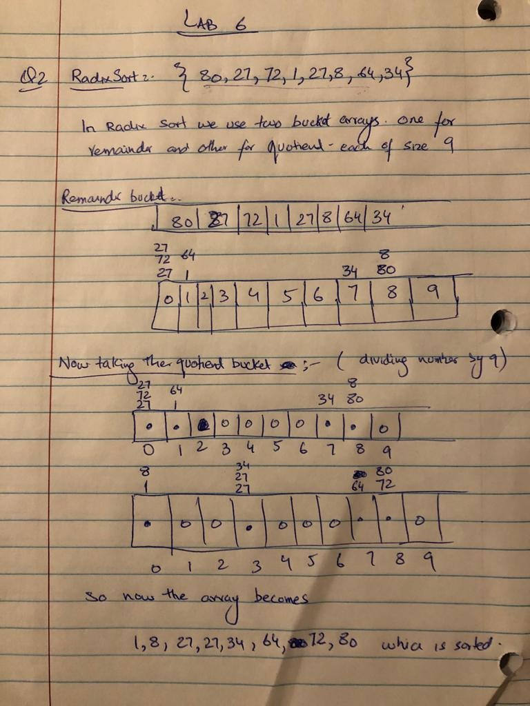
- Describe an O(n) algorithm that does the following: Given an input array of n integers lying in the range 0 .. 3n - 1, the algorithm outputs the first integer that occurs in the array only once. (You may assume that each input array contains at least one number that has no duplicates in the array.) Explain why your algorithm has an O(n) running time.

Example: If the input array is [1, 2, 4, 9, 3, 2, 1, 4, 5], then the return value is 9 since 9 is the first integer that occurs in the array only once.
Solution:

Let Inputarr represents the initial input array and bucketarr is a tracking array which keeps records of duplicates numbers.

Input: An array with n positive integers
Output: A positive integer.

bucketarr←new array[3n] (Initialized with 0,s)
for (i←0 to n-1) do
x←inputarr[i]
bucketarr[x] ←bucketarr[x]+1
for (i←0 to n-1) do
x←inputarr[i]
if(bucketarr[x]=1) then
return x

- The Fibonacci numbers are defined in the following way:

F (0) = 0, F (1) = 1, F(n) = F(n-1) + F(n-2)

- Devise a recursive algorithm for computing the nth Fibonacci number.

- Can you use one of the techniques in lesson 2 to compute the running time of your recursive algorithm?

- Devise an iterative algorithm for computing the nth Fibonacci number.

- What is the running time of your iterative algorithm?

Solution:
- Input: An Integer n to find nth Fibonacci number
Output: An Integer n to give nth Fibonacci number

If(n<=1) then +1
return n +1
[else]
return Fibonacci(n-1) + Fibonacci(n-2) T(n-1) + T(n-2)
- To find the running time of the recursive algorithm, we use Master formula or Counting Self calls.
Master Formula:
We cannot calculate the running time using master formula as its not according to the specific format so we will try using Self Counting calls.
Self-counting calls:
By counting the primitive operations of the above algorithm, we came to know that
T(n)=T(n-1) +T(n-2) + Constant (which in this case is +2)
So, there is no specific series for that format so we can’t count using this also.
- Iterative Algorithm:

Input: An integer n to find the nth Fibonacci Number
Output: An integer which gives the nth Fibonacci Number

first←0
previous←1
sum←0
if(n==0 OR n==1) then
return 1

for(i←0;i<n-1;i++)
sum←first+previous
first←previous
previous←sum

return sum

- As according the Rule number 1 , the running time of our Iterative algorithm is O(n)+constant which we can say that
T(n)=O(n)

